CHARTING THE COURSE OF INNOVATION: A STARTUP ANALYSIS

1.INTRODUCTION

1.1.OVERVIEW

Flashes of insight, strokes of genius, and sudden bolts of inspiration often spring to mind when we envision the practice of delivering game-changing business advancements. But while ideation is a critical component of building an innovative culture, by itself it’s not enough to drive transformative breakthroughs for today’s enterprise, given the speed, scale and level of complexity at which the commercial world now operates. Rather, as Harvard professor Gary P.

Pisano notes, [modern organizations need to adopt a well-planned innovation strategy](https://hbr.org/2015/06/you-need-an-innovation-strategy): a set of systemized actions, behaviors, policies and procedures that work toward achieving a specific competitive goal and lay the groundwork for ongoing corporate evolution and advancement.

1.2. PURPOSE

Simply put, innovation is about successfully implementing a new idea and creating value for your customers and stakeholders. Innovation starts with a new idea. It could be a plan for an improved product or service; it could be an updated method for running your operations; it could also be a new business model.

In a business context, innovation is the ability to conceive, develop, deliver, and scale new products, services, processes, and business models for customers. For a startup to succeed, there are generally three core components making up that success: a strong product, a well-researched go-to-market strategy, and a strong organizational culture. Each of these components can be a struggle to get right individually—and ensuring each of them works together can be even bigger.

2. PROBLEM DEFINITION AND DESIGN THINKING

2.1.EMPATHY MAP

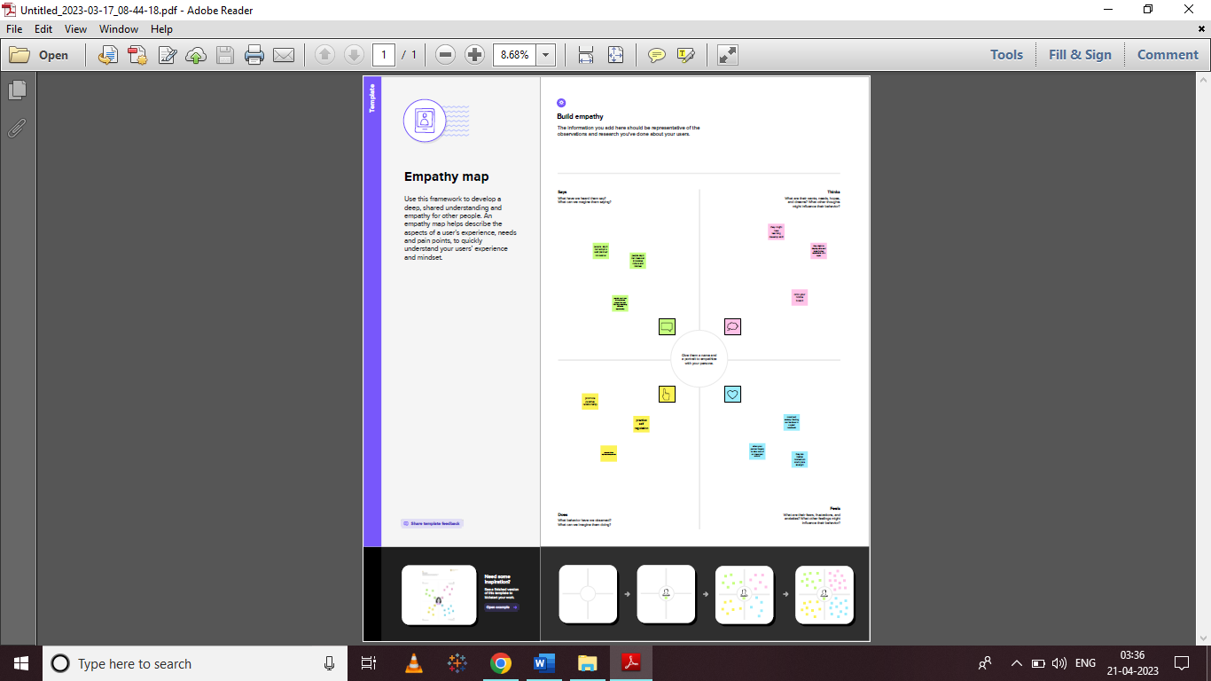

2.2.IDEATION AND BRAINSTROMING MAP

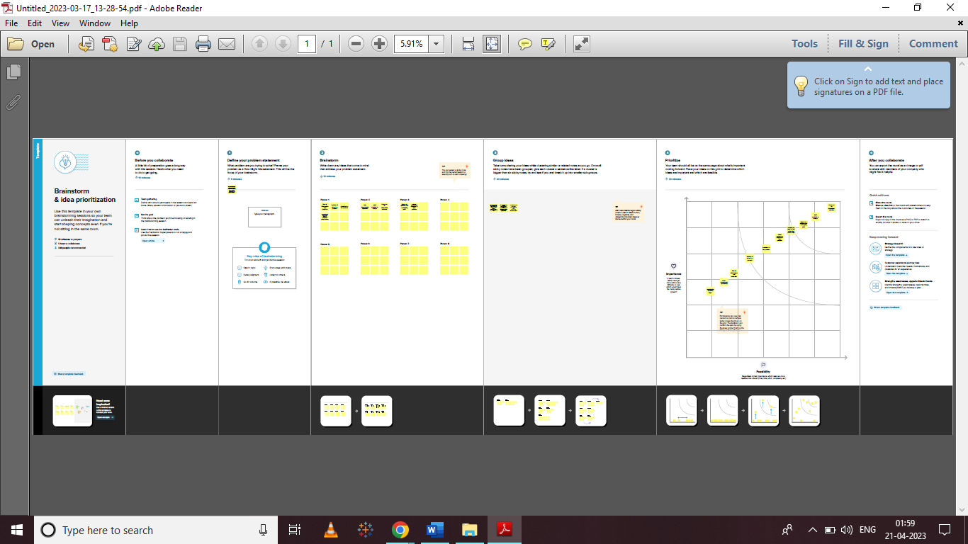

**3.RESULT**

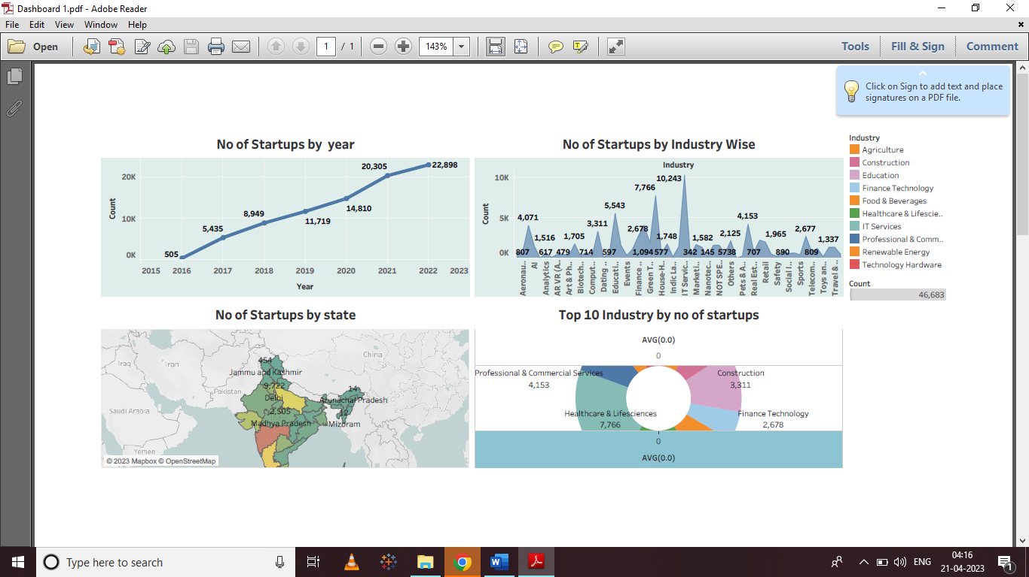

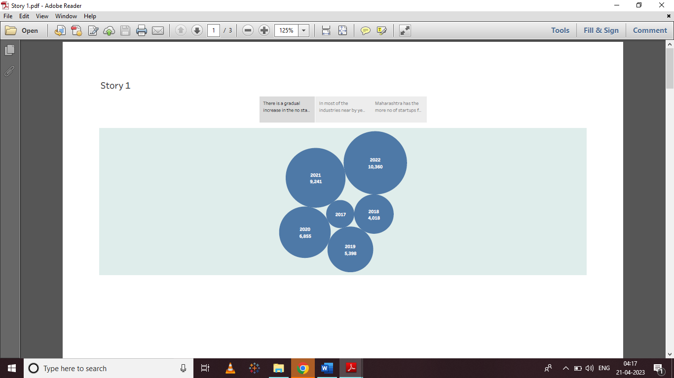

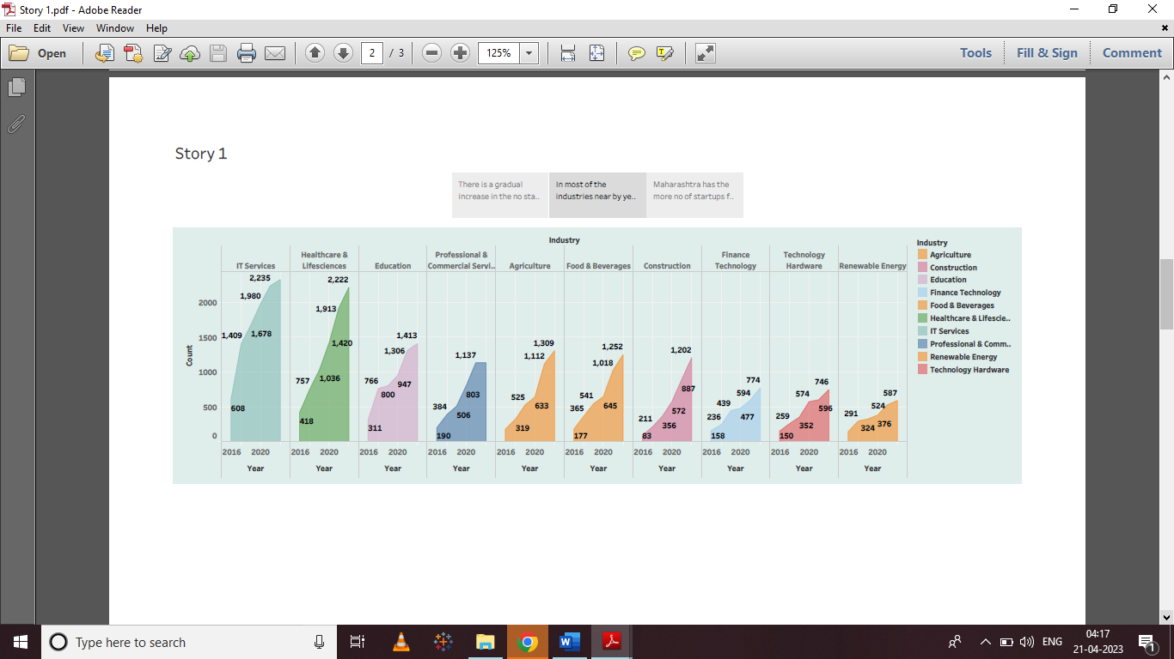

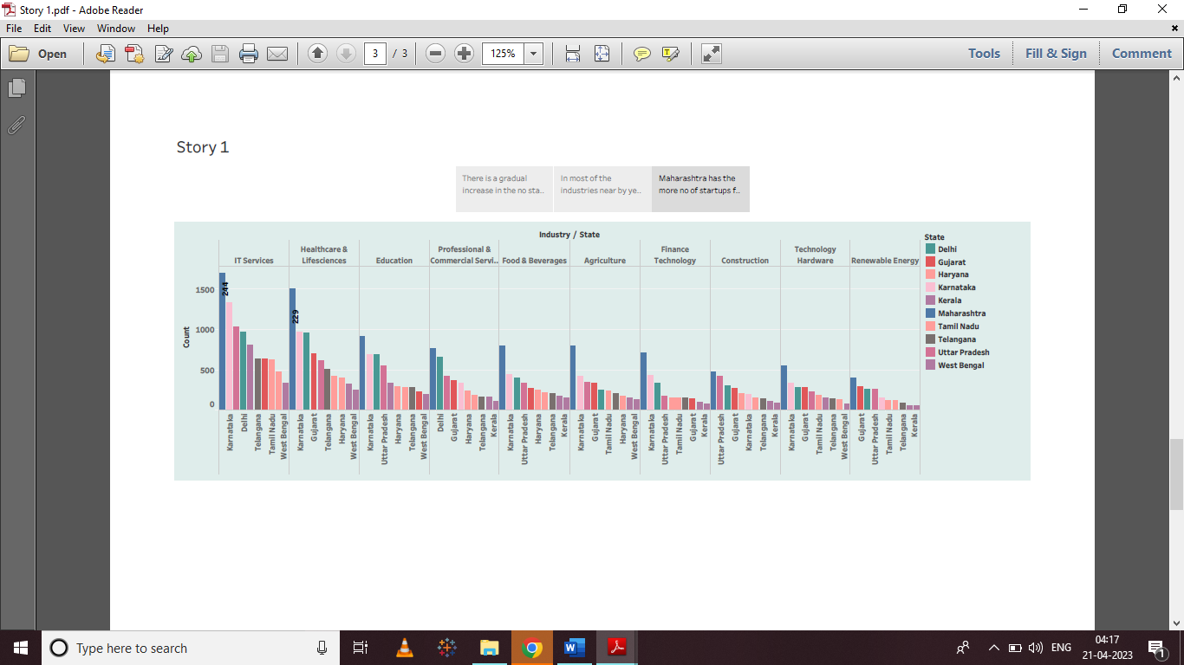

**4.ADVANTAGES AND DISADVANTAGES**

**ADVANTAGES**

* Charts enable you to visually compare multiple sets of data.
* Charts can help people better understand and remember information.
* Many people understand a picture more quickly than blocks of text.
* A compelling chart can help you make your point more convincingly and lend credibility to your presentation.
* Charts enable you to visually compare multiple sets of data.

**DISADVANTGES**

* However, graphs and charts also have some disadvantages that you need to be aware of.
* One of the main disadvantages is that they can be misleading, confusing, or inaccurate if they are not designed, labeled, or interpreted correctly.
* A disadvantage of using a chart is that, by design, a chart will likely not be as precise as the raw data.

**5.APPLICATION**

 Charting software enables traders to generate charts and conduct technical analysis on stock charts, crypto charts, and forex charts. Charting software platforms provide an important trading tool for asset traders to test and execute trading strategies.

You can create a chart for your data in Excel for the web. Depending on the data you have, you can create a column, line, pie, bar, area, scatter, or radar chart. Click anywhere in the data for which you want to create a chart. To plot specific data into a chart, you can also select the data.

Charting software is a type of software designed to assist in the analysis and tracking of financial markets. It can be used to create, store, and analyze data related to stocks, commodities, mutual funds, foreign trade (Forex), indices, futures contracts, and other financial instruments.

Digital charting allows you to transport and take your notes wherever you are. You can access your files from a laptop, desktop, tablet, or mobile phone. This means no more late nights at the office, and you can finally achieve the work-life balance that every private practice owner needs.

**6. CONCLUSION**

 Every innovation, whether it comes in the form of a new product or the total reimagining of what a product can be, points to previously unimagined possibilities for connecting, improving, and transforming the world.

On taking a deeper look at the untapped quadrant in the bottom left, we can see expected growth in market sizes for the three most promising AI applications.

Based on our research, we believe that the future of AI cannot be captured in a homogenous manner. AI will progress depending on the specifics of the application and data availability is crucial to determining the rate of development. While this analysis presents a unique way to view AI and its growth, it is not nearly the end of AI development research. We hope to continue to see many others attempt to map out this difficult market.

**7. FUTURE SCOPE**

The workshop provided an opportunity for the Roundtable to hear presentations on the totality of water issues. Many participants agreed that we have made progress since the passage of the Safe Drinking Water Act and the Clean Water Act because they were instrumental in providing the first steps to ensure the availability of water for current and future populations. Henry Falk, assistant administrator of the Agency for Toxic Substances and Disease Registry (ATSDR) and director of the National Center for Environmental Health (NCEH) at the Centers for Disease Control and Prevention (CDC), observed that these regulations served as a means to enact some of the most beneficial and readily available measures. However, he noted that the remaining issues are complex, often have societal and personal implications, and are not fixed by quick regulatory decision. Panelists and participants discussed many of these issues including a paradigm shift, research needs, educational needs, and other challenges ahead.

National Academies of Sciences, Engineering, and Medicine.